WHAT YOU CAN DO
Protect our air!
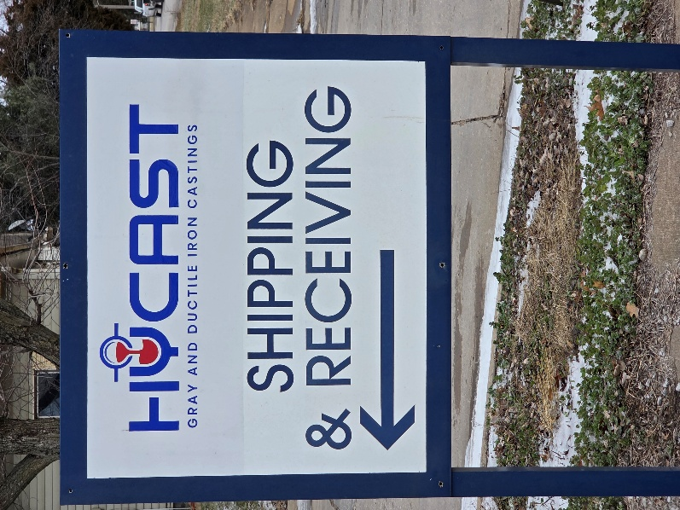
- PUBLIC INFORMATION MEETING:
Saturday, January 17th , 2:00 P.M., Fairfield Public Library.
- COMMENT (written or emailed): The Iowa Department of Natural Resources (IDNR) is accepting comments until February 2, 2026. For additional information, a copy of the draft permit, a fact sheet, or to submit a comment, contact:
Zane Peters, IDNR - Air Quality Bureau
6200 Park, Ste #200
Des Moines, Iowa 50321
Phone: (515) 808-0458
e-mail: zane.peters@dnr.iowa.gov
- SIGN THE PETITION: Tell Iowa DNR NOT to renew the draft Operating Permit for Hycast, LLC Foundry.

- PUBLIC HEARING VIA ZOOM:
Register here: https://tinyurl.com/Fairfield-Clean-Air and comment at the public hearing Thursday, January 29th, 2026, from 7:00-9:00 p.m.

